Phase 5 – Deployment, Documentation and Final Presentation
Document Functional Overview

Phase Overview
This document provides a comprehensive functional overview of the metro ticket booking system developed using ServiceNow. It explains how the system operates from user input to ticket generation, focusing on form variables, user experience flow, and QR code mapping.

1) Purpose
The purpose of this document is to clearly define the functional components of the system and explain how users interact with the application. It ensures that stakeholders, administrators, and future developers understand the system behaviour and data flow.

2) Form Variables Definition
A) Variable Structure
The service catalog form includes well-defined variables to capture all necessary ticket booking details. Each variable is designed with appropriate data types, labels, tooltips, and validation rules to ensure accurate data entry.

B) Variable Behaviour
Variables are configured with conditional logic using UI policies and client scripts. Certain fields appear or auto-populate based on user selections, reducing manual effort and improving form usability. Mandatory and read-only settings ensure data consistency.
3) User Experience Flow
A) Booking Journey
The user experience flow begins when a commuter accesses the Service Portal and searches for the Book A Metro Ticket catalog item. Users fill in journey details, passenger information, and payment preferences before submitting the request.

B) Submission and Confirmation
Upon submission, the system generates a request and requested item (RITM). Users can view booking details and receive confirmation through the portal, ensuring transparency and clarity throughout the process.
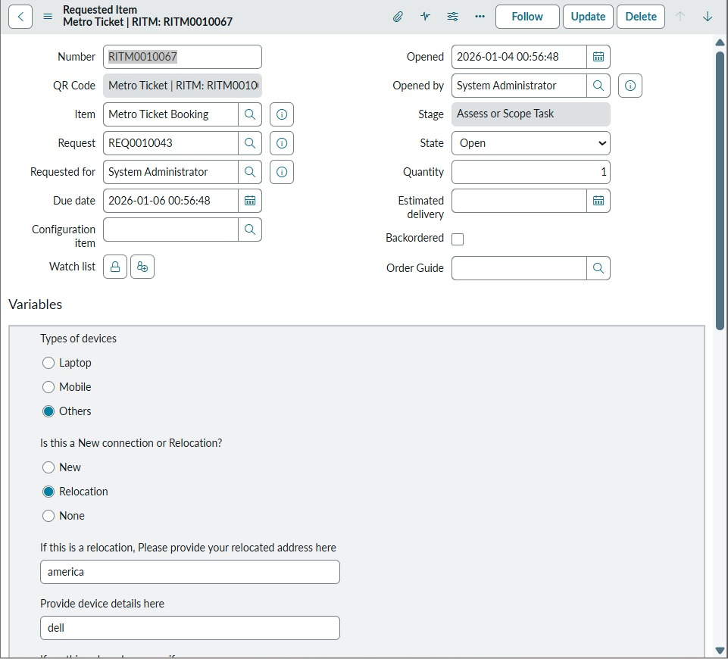
4) QR Code Mapping Process
A) QR Code Generation Logic
The QR code generation process is triggered during form submission using a catalog client script. The system generates a unique identifier and maps it to ticket details, ensuring each ticket is uniquely identifiable.

B) QR Code Usage
The generated QR code is displayed to the user through a modal window and can be scanned at metro entry points for ticket validation. This enables paperless travel and improves operational efficiency.

5) Outcome
The functional overview confirms that the system provides a clear, user-friendly booking experience with structured data capture and secure QR-based ticketing. The design supports automation, scalability, and ease of maintenance.

